**SYNOPSIS1**

Project Duration: 60 Hours

项目持续时间：60小时

**INTRODUCTION:**

**介绍：**

**Objective:** The objective of the **“Library Management Software”** is to handle the entire activity of a library. The software keeps track of all the information about the books in the library, their cost, their complete details and total number of books available in the Library. The user will find it easy in this automated system rather than using the manual writing system. The system contains a database where all the information will be stored safely. The system is user-friendly and error free.

目标:“图书馆管理软件”的目标是处理图书馆的整个活动。该软件跟踪所有图书馆里的书籍的信息，包括他们的成本，他们完整的细节和图书馆里书籍的总数。用户会发现使用这个自动化系统很容易，而不是使用手工书写系统。该系统包含一个数据库，在那里所有的信息都将被安全地存储。该系统是用户友好和无差错的。

**Scope:**The Library Management System is designed for managing various activities of “Central University Library”. Since library has a very large number of books and a large number of members, it is impossible for librarian to manage day to day activities manually.

图书馆管理系统是专为管理“中央大学图书馆”的各种活动而设计的。由于图书馆有非常大量的书籍和大量的成员，图书管理员不可能手动管理日常活动。

**PROJECT CATEGORY:**

RDMS

项目类别：RDMS

**PROJECT DESCRIPTION:**

**项目描述：**

The software to be produced is on **Library Management System**. Here there are 2 users. They are The Admin and the Library members. The first procedure is the online registration of the people who visit to the online library. A membership number will also be provided to the registering members. A member can also block the book for particular days. All the information will be entered in the system. If the person doesn’t return the book before the due date, a fine will be added and the notification will be sent to that particular person about the fine.

Admin has the authority to add, delete or modify the details of the book available to/from the system. He also has the authority to block membership of defaulters or inactive users. He can also add the details of the book purchased from shops along with the shop name. Monthly expense report, books purchased report, cash collected for fee can also be viewed.

要制作的软件在图书馆管理系统中。这里有2个用户。他们是管理员和图书馆成员。第一个程序是访问在线图书馆的人员的在线注册,还将提供成员数给注册成员。成员也可以在特定天数内借这本书。所有的信息将在系统中输入。如果有人没有在到期日之前归还这本书，将被添加罚款，并收到通知。

管理员有在系统中添加，删除或修改书的细节的权限。他也有权阻止违约或非活跃用户的会员资格。他还可以添加从商店购买的书的细节以及商店名称。每月费用报告，图书采购报告，收取现金的费用也可以查看。

**An Overview of Modules of the software:**

**软件模块：**

* **Books:** Admin has the authority to add, delete or modify the details of the book available to/from the system.
* **图书：管理员有从系统添加，删除或修改书的细节的权限。**
* **Role based Login:** Both the Admin and the Member can choose to Login based on their role
* **基于角色的登录：管理员和会员都可以根据自己的角色选择登录**
* **Online Registration:** The first procedure is the registration of the people who visit the application online. The user has the fill registration form to enter the name, address and contact number, valid identification card
* **在线注册：第一个程序是在线访问应用的人的注册。用户有张登记表来填写姓名、地址和联系号码，有效身份证**
* **Time spent:** Their online log in and log out should be stored based on their login frequency. This calculates the total amount of time they spent on the site library. An inactive user must be logged out after 10 minutes.
* **时间：他们的在线登录和注销应根据他们的登录频率存储。这计算了他们在图书馆网站上花费的总时间。不活动的用户必须在10分钟后注销。**
* **Purchase books:** Admin can also add the details of the book purchased from different suppliers along with their details. All these suppliers must register them self with the Library first. He also has the authority to delete from or modify it to-from the database.
* **购买书籍：管理员也可以添加从不同的供应商购买的书的细节以及他们的细节。所有这些供应商必须先在图书馆注册他们自己。管理员也有权从数据库中删除或修改它。**
* **Borrow books:** A person can also borrow the book for particular days. All the information will be entered in the system. If the person doesn’t return the book before the due date, a fine will be added and the information will be sent to that particular person about the fine.

**借书：一个人也可以特定天数内借这本书。所有的信息将输入系统中。如果人没有在到期日之前归还这本书，他将被增加一个罚款，并收到信息。**

* + **A** valid normal member can block maximum of 4 books
  + **一个有效的正常成员最多可以借四本书**
  + **A VIP** member can block maximum of 10 books at a time
  + **VIP成员最多可借10本书**
* **Login registration:** Admin also has the authority to block username and password for the defaulters.
* **登录注册：管理员也有权限制违约者的用户名和密码。**
* **Reports:**

**HARDWARE REQUIREMENTS:**

* **Processor:** Intel dual core or above
* **Processor Speed:**1.0GHZ or above
* **RAM:** 1 GB RAM or above
* **Hard Disk:** 20 GB hard disk or above

硬件要求：

处理器：英特尔双核或以上

处理器速度：1.0GHz以上

内存：1 GB RAM或以上

硬盘：20 GB硬盘或以上

**SOFTWARE REQUIREMENTS:**

* **Language:** Java EE Platform | PHP
* **Other Skills:** Design Pattern | HTML-5
* **Database:** My SQL

软件需求：

•语言：java EE平台| PHP

•其他技能：设计模式| HTML 5

•数据库My SQL

**CONCLUSION:**

**Library Management System** allows the library management to have an online process and cater to more readers and their requirements. This online application allows storing the details of all the data related to library. The system is strong enough to withstand regressive yearly operations under conditions where the database is maintained and cleared over a certain time of span. The implementation of the system in the organization will considerably reduce data entry, time and also provide readily calculated reports.

图书馆管理系统允许图书馆管理有一个在线程序，并满足更多的读者和他们的要求。此在线应用程序允许存储与图书馆相关的所有数据的详细信息。这个系统强大到可以承受逐年减少对数据库定期维护和清理的情况。系统的实施将大大减少数据输入，时间，并提供容易计算的报告。

**Core Features (Process details):**

**核心功能（程序细节）：**

**Library Admin:**

**图书馆管理员：**

1. Can perform CRUD (Create | Read | Update | Delete) operations in the Library database

可以在Library数据库中执行CRUD (Create | Read | Update | Delete) 操作

1. Update the inventory

更新库存

1. Can Approve or Deny issue of the book for any member

可以批准或拒绝任何一本书的借出

**REPORTING:**

**报告：**

1. View details of the books that are issued

查看已被借出的书的详细信息

1. View details of the book are not returned by the user

查看没有被用户归还的书的详细信息

1. Cancel the membership, if required

如果需要的话取消会员资格

1. View total stock in the library book wise / publisher wise

按图书馆图书/出版商查看总库存

1. View Monthly / Weekly details of the books that have been issued

查看已被借出的书籍的月/周详细信息

1. Revenue collected from the Courier services offered to customer

提供给客户的快递服务的总收入

1. Revenue collected from the fine imposed on the user

从用户收取的罚款总收入

1. View summary of total requests that has been made, pending or approved status of those request.

查看所有请求的状态，包括已完成的，挂起或已批准的

**Membership Application:**

**会员申请：**

1. Anyone with a valid identification can register online to be a member of the library

任何有有效的身份证的人都可以在网上注册成为图书馆的一员

* 1. Members can log in and log out

会员可以登录或注销

* 1. If logged in successfully, redirected to a personalized dashboard

如果登录成功，重定向到一个个性化的桌面

* 1. Members can search for books

会员可以搜索书籍

* 1. View details of the book and its status such as available or issued

可以查看书籍的信息和状态，比如可以借阅或已被借出

* 1. If available, then members can request to get it issued

如果可以借阅，会员可以要求借出这本书

* 1. If already issued, then can raise a request in advance after its returned

如果已被借出，则可以在其返还后提前提出请求

* 1. Member can choose to be a:

会员可以选择成为：

* + 1. VIP member of the Library

图书馆的VIP会员

* + - 1. VIP members can view list of books and download the PDF version of the same

VIP 会员可以查看图书列表并下载PDF版本

* + 1. Normal Member

普通会员

* + - 1. Normal Member can view list of books but cannot download the PDF version of the same

普通会员可以查看图书列表但不能下载PDF版本

* + - 1. Normal users be allowed to change their membership to VIP

普通用户可以将会员资格改为VIP

1. Normal Member can issue the available book online and choose to have it delivered to their given address or pick by them self. 、

普通会员可以在线借阅可用的书本以及选择运送书本到他们填写的地址。

* 1. Need pay for the courier charges

需要支付快递费用

* 1. The Delivery service is only applicable to certain part of the city only

仅在市中心提供运送服务

1. VIP members can get the books delivered to their home address within 5 KM for free

VIP会员可以享受5公里内免费送书到家的服务

1. Member will need to return the book after 1 week from the date of issuing of the book

会员需要在借阅后的一周内归还图书

* 1. In case of a failure to return the book, a member need to pay the fine:

关于未能按期归还图书的罚款措施

* + 1. <7= 50 RMB

小于等于7日，罚款50元

* + 1. After 7 days, 5 RMB per day

大于7日的，按每天5元罚款

* + 1. Member should get a notification to return the book on time

会员应当收到按时还书的通知

* 1. Member also have an option of raising a reissue request for the same book.

会员也有对同一本书提出续借要求的选项

* + 1. Library admin can approve the request

图书馆管理人员可以批准这个要求

* + 1. Member cannot hold the book for more than 1 month

会员不能续借书本超过1个月

1. If a book is already issued in the name of another member, they can request for its booking after the return date of the book

如果书本已经借给了其他会员，他们可以在归还日期后要求预定

* 1. In case the book is not returned by its existing holder then a notification should be sent to the user who has issued a request for the same

如果书本没有被现在持有人归还，应当通知预定这本书的用户

* 1. In case the book is returned, it is automatically given to the user who has applied for it and a notification is sent to the same user for the same

如果这本书已经被归还，自动分配给已预定的用户，并且通知其他预定这本书的用户。

**REPORTING DASHBOARD MODULE:**

**报告指示板模块**

1. View details of the books borrowed so far

查看至今为止被借图书详情

1. View date wise return summary of the borrowed books

根据日期查看书籍的返还情况

**Checklist & Development milestone:**

**检查清单和开发里程碑**

1. Requirement Analysis of the project

项目的需求分析

1. Case Diagram & required application modelling using UML

用例图和通过UML建立的需求应用模型

1. Set up development standards

建立开发标准

1. ERP Modelling and Database Designing / Table formation

ERP 建模和数据库设计/建立表格

* 1. Tables

表格

* + 1. Table Columns & Data types

表格的列和数据类型

* 1. Constraints, if applicable

约束，是否适用

* 1. Procedures to be created

创建程序

1. Application Design & Flow

应用程序设计和流

1. Clarity on the Application Logic

使应用程序逻辑清晰

1. Data access strategy

数据访问策略

1. Separation of Application components in to Model / View / Controller

将应用程序组件分成模型/视图/控制器

1. Division of Tasks among the team members under a team leader

组长进行任务分工

1. Development progress review schedule

开发进度评审计划

1. Kick start Application Development

启动应用程序开发

1. Debugging

调试

1. Testing (Work on test cases to be developed and used, types of testing such as Load testing, performance testing, application logic testing)

测试（进行用例的开发与使用的测试，例如负载测试，性能测试，应用程序逻辑测试）

1. Deployment

部署

1. Real time access & resolving reported technical issues

实时访问和解决上报的技术问题

1. Project Dry Run

项目演练

1. Final Project Presentation

最终项目展示

**Time Spend (Daily Project Activity Tracker-Sample Table for Reference)**

**时间花费（每日项目活动跟踪示例表 供参考）**

|  |  |  |  |  |
| --- | --- | --- | --- | --- |
| **Serial#** | **Date** | **Work Done** | **Time hours** | **Group Members** |
| **1** | **10/9/2016** | **Analysis**  **分析** | **2** | **All group members are present**  **所有成员** |
| **2** | **10/9/2016** | **ERD**  实体关系图 | **2** | **All group members are present**  **所有成员** |
| **3** | **10/9/2016** | **Normalization**  **标准化** | **2** |  |
| **4** |  | **Data base**  **数据库** | **1** |  |
| **5** |  | **Table Formation**  **创建表** | **1** | **John** |

**SAMPLE SEQUENCE DIAGRAM (For Reference)**

**样本序列图（供参考**

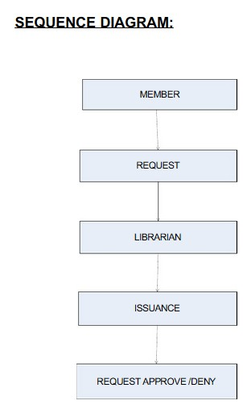

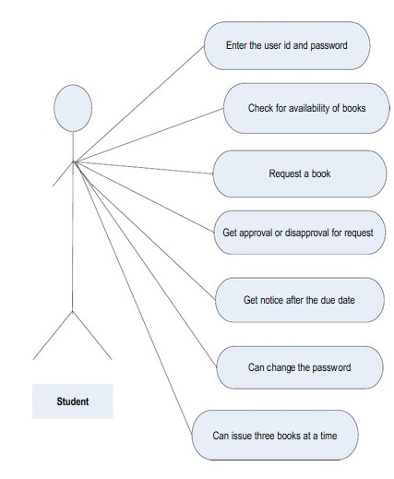

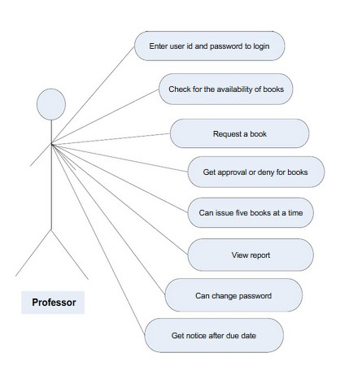

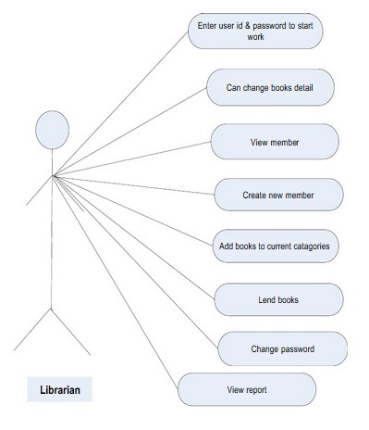

**SAMPLE DATA FLOW DIAGRAM (For Reference)**

**样本数据流图（供参考）**



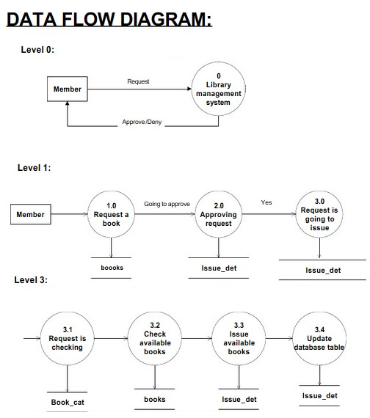

**SAMPLE E样本ER图**

**R DIGRAM**

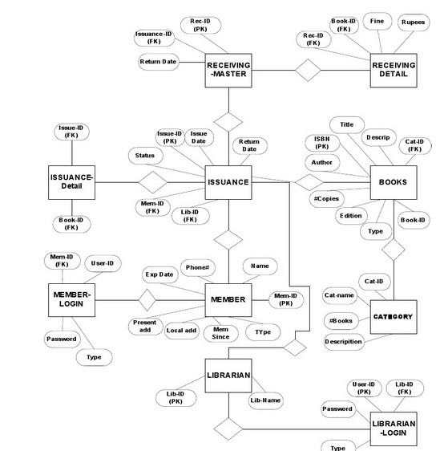

**SAMPLE DATABASE DESIGN (For Reference)**

**样本数据库设计（供参考）**

**Tables of Library Management System:**

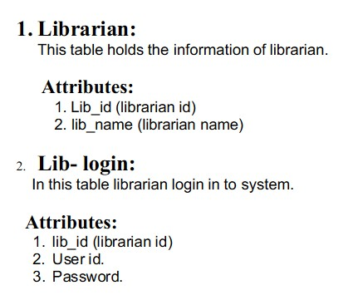

1.这个表包含了图书管理员的个人信息..

2.这个表包含了图书管理员的登陆信息..

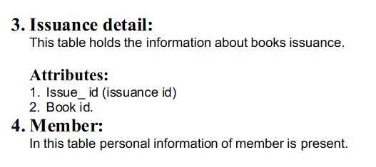

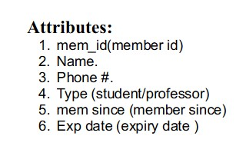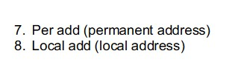

3.这个表包含了书籍的出借信息.

4.这个表包含了成员的个人信息.

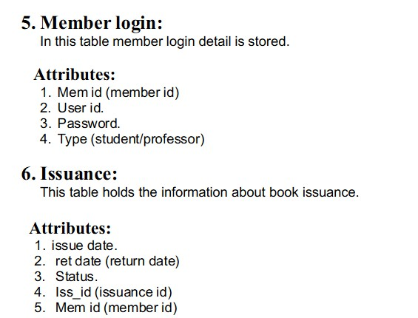

5.这个表包含了成员的登陆信息.

6.这个表包含了书籍的出借细节.

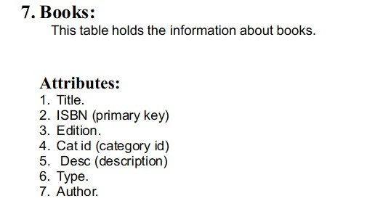

7.这个表包含书籍的信息.

C:\Users\Shahnawaz\AppData\Roaming\Tencent\Users\2998971951\QQ\WinTemp\RichOle\523AGRHQKR8S9ZL[$P_O~`7.jpg

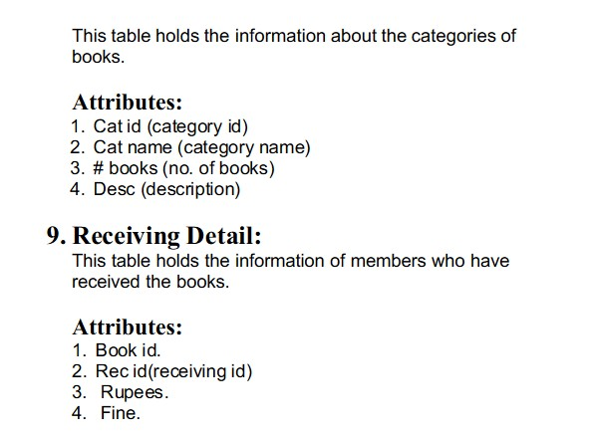

8.这个表包含书籍的类别信息.

9.这个表包含收到书本的成员的信息.

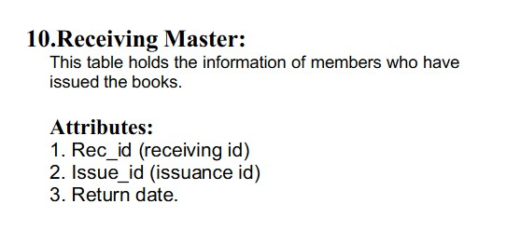

10.这个表包含着发行书本的成员的信息.